England Netball hosts the ParaNetball Championships
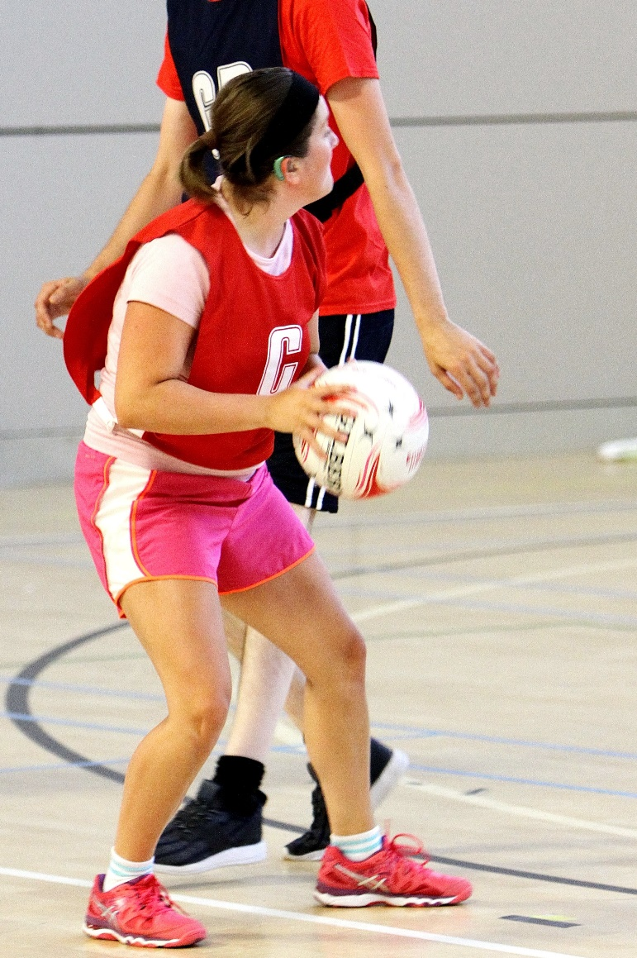

Date: Saturday 1st February 2020

Venue: Lee Westwood Sports Centre, Nottingham Trent University, NG11 8SN

Divisions:
Learning Disability
Deaf and hard-of-hearing

Entry Deadline: Monday 13th January 2020

Email entry forms to compevents@englandnetball.co.uk
Availability is limited, places will be awarded on a first come first served basis.

Individual Player(s) Registrations

Player | Name | D.O.B. | Gender | Disability | Photo Permissions*
1 |  | / / |  |  | ☒
2 |  | / / |  |  | ☒
3 |  | / / |  |  | ☒
4 |  | / / |  |  | ☒
5 |  | / / |  |  | ☒

Main contact for the above Players:
Name | Contact Number | E-mail Address

Main Contact Signature:
*Please mark the box with an “x” to confirm this player is available to be photographed by England Netball as part of the event, which may be shared as part of the England Netball media channels. More information on the media policy can be found: https://www.englandnetball.co.uk/england-netball-privacy-policy/

