England Netball hosts the ParaNetball Championships for people with Special Educational Needs and Learning Disabilities.

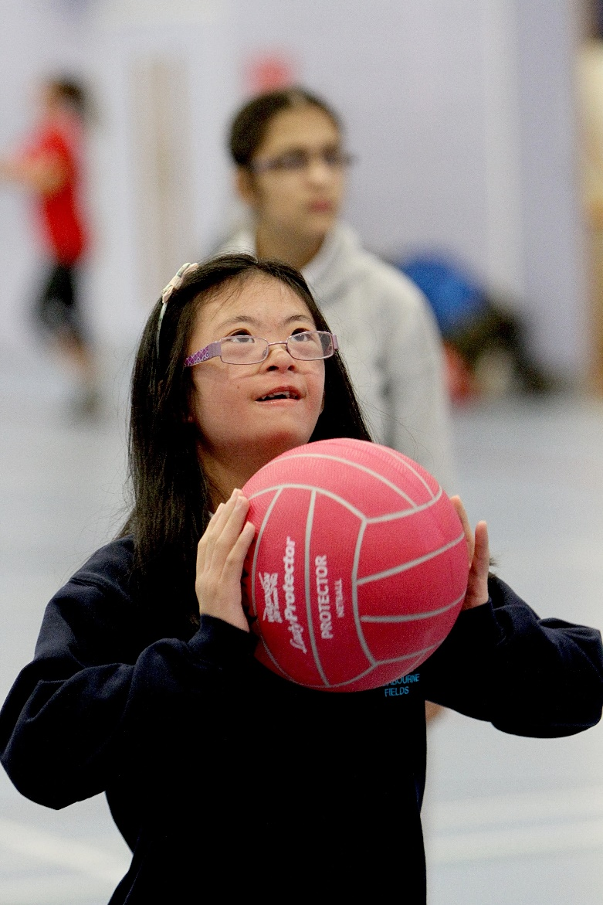
Date: Saturday 1st February 2020

Venue: Lee Westwood Sports Centre, Nottingham Trent University, NG11 8SN

Entry Deadline: Monday 13th January 2020

Price: England Netball Members – Free
Non-Members - £50

Email entry forms to compevents@englandnetball.co.uk
Availability is limited, places will be awarded on a first come first served basis.

Name of Club: Region:

Kit Colours – Skirt/ Shorts: Shirt: Bibs: Dress:

T | Name | D.O.B. | Gender | Disability | Photo Permissions*
1 |  | / / |  |  | ☒
2 |  | / / |  |  | ☒
3 |  | / / |  |  | ☒
4 |  | / / |  |  | ☒
5 |  | / / |  |  | ☒
6 |  | / / |  |  | ☒
7 |  | / / |  |  | ☒
8 |  | / / |  |  | ☒
9 |  | / / |  |  | ☒
10 |  | / / |  |  | ☒
11 |  | / / |  |  | ☒
12 |  | / / |  |  | ☒
Team Officials | Name | Phone Number | Any additional requirements for your team
Head Coach
Primary Carer
Team Official 3
Team Official 4
Scorer *
Emergency Contact
Team Manager / Coach Signature:
*Please mark the box with an “x” to confirm this player is available to be photographed by England Netball as part of the event, which may be shared as part of the England Netball media channels. More information on the media policy can be found: https://www.englandnetball.co.uk/england-netball-privacy-policy/

